Week 2 Lab Task
Information Gathering (OSINT)
NIAI NAVTTC — Certified Ethical Hacker (CEH) Course
⚠ Important: All tasks are performed only in your isolated virtual lab environment.
Prepared by : Usman Shakir
▶ Choose a Safe Practice Domain
Use certifiedhacker.com — this is a deliberately vulnerable site made for training.
▶ WHOIS Lookup — Find Domain Owner
Run in Kali terminal:
whois Certifiedhacker.com
Note the registrar, creation date, name servers, and contact details.
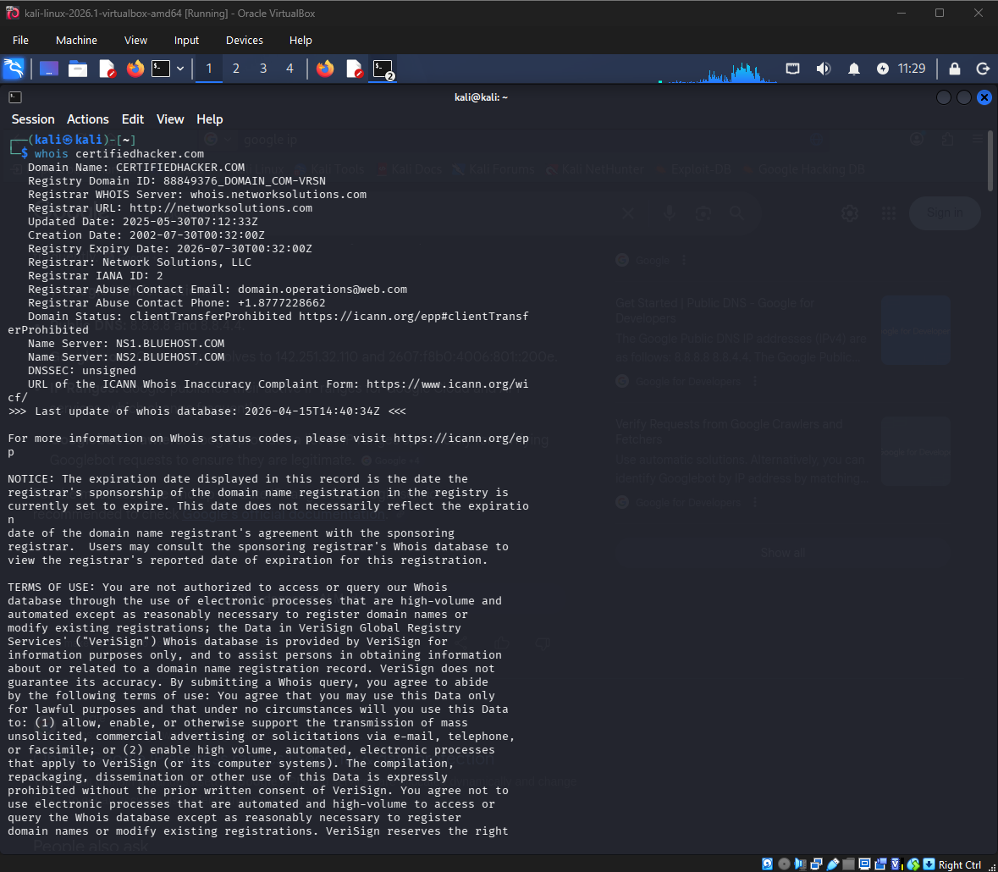
▶ DNS Enumeration
nslookup Certifiedhacker.com
host Certifiedhacker.com

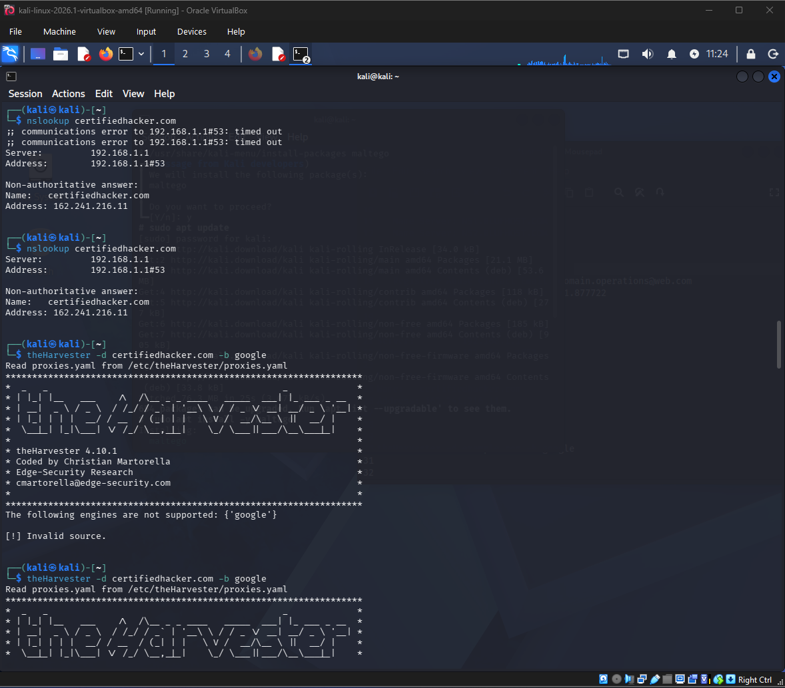

▶ theHarvester — Gather Emails & Subdomains
theHarvester -d certifiedhacker.com -b google
Replace example.com with your target domain. This finds emails and subdomains indexed by Google.

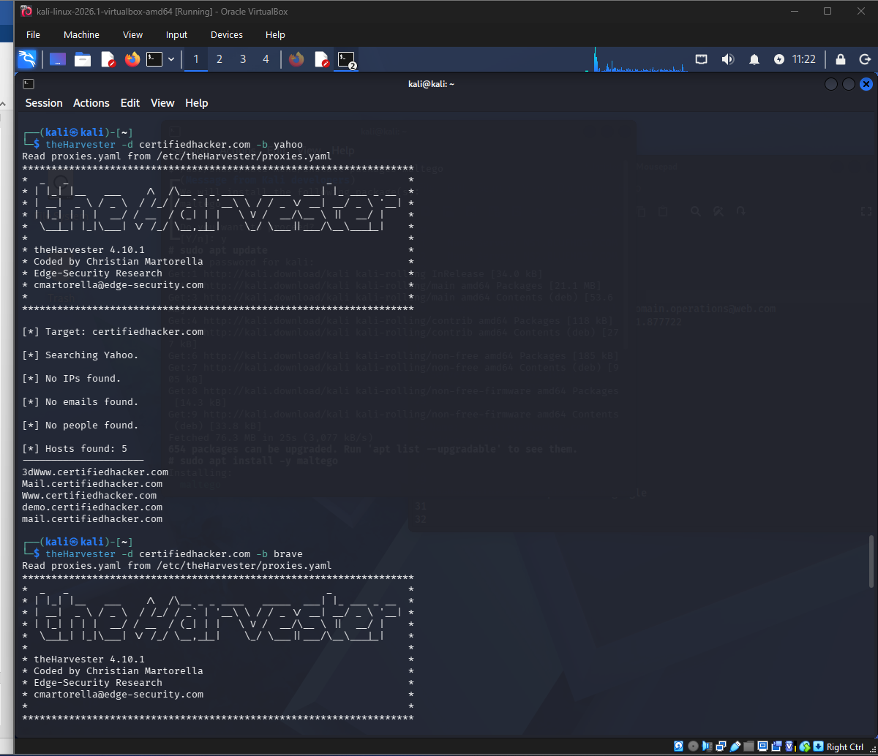

▶ DNSDumpster — Check Exposed Services
Go to DNSDumpster in your browser.
Search the domain name or its IP address.
Note what ports and services are publicly visible (e.g. open port 22, 80, 443)
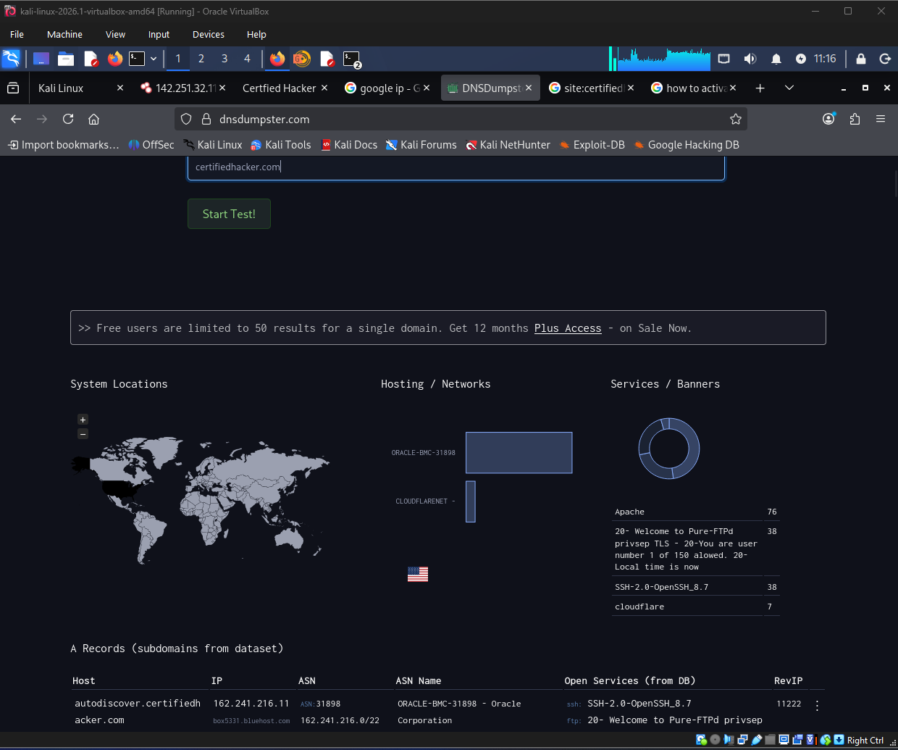
Open Ports
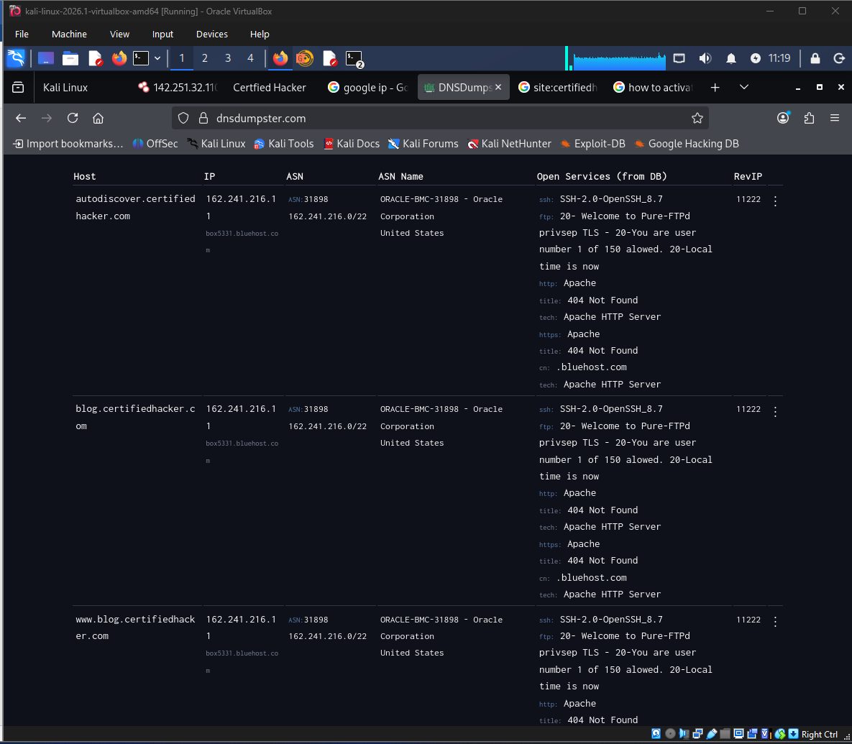

▶ Google Dorks — Find Indexed Pages
In Google browser, search:
site: certifiedhacker.com
intitle:index.of certifiedhacker.com
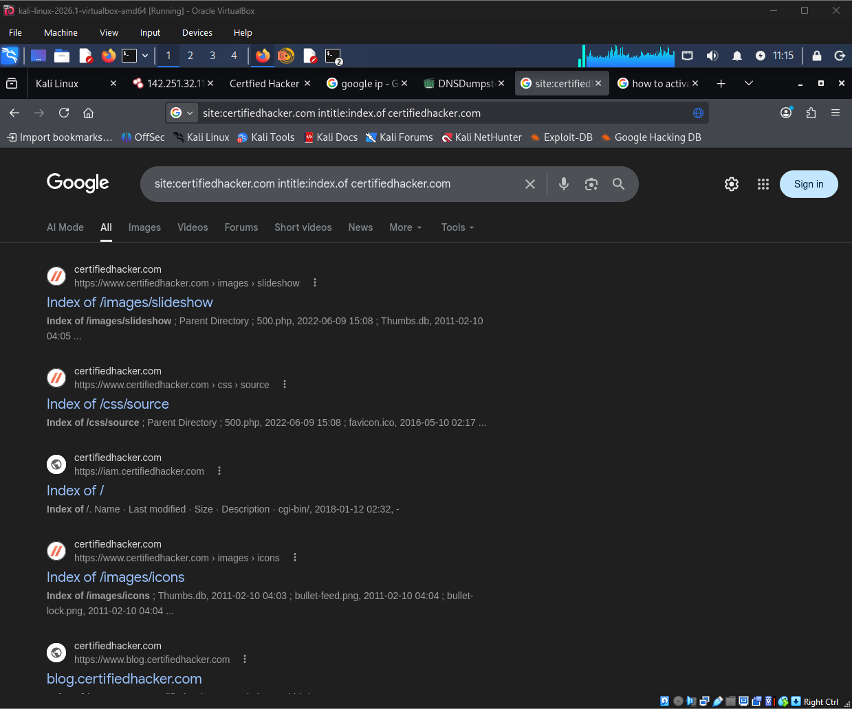

▶ Maltego (Optional — Visual Link Analysis)
Open Maltego from Kali applications menu.
Create a new graph and add the target domain as an entity.
Run transforms to visually map emails, IPs, and subdomains.
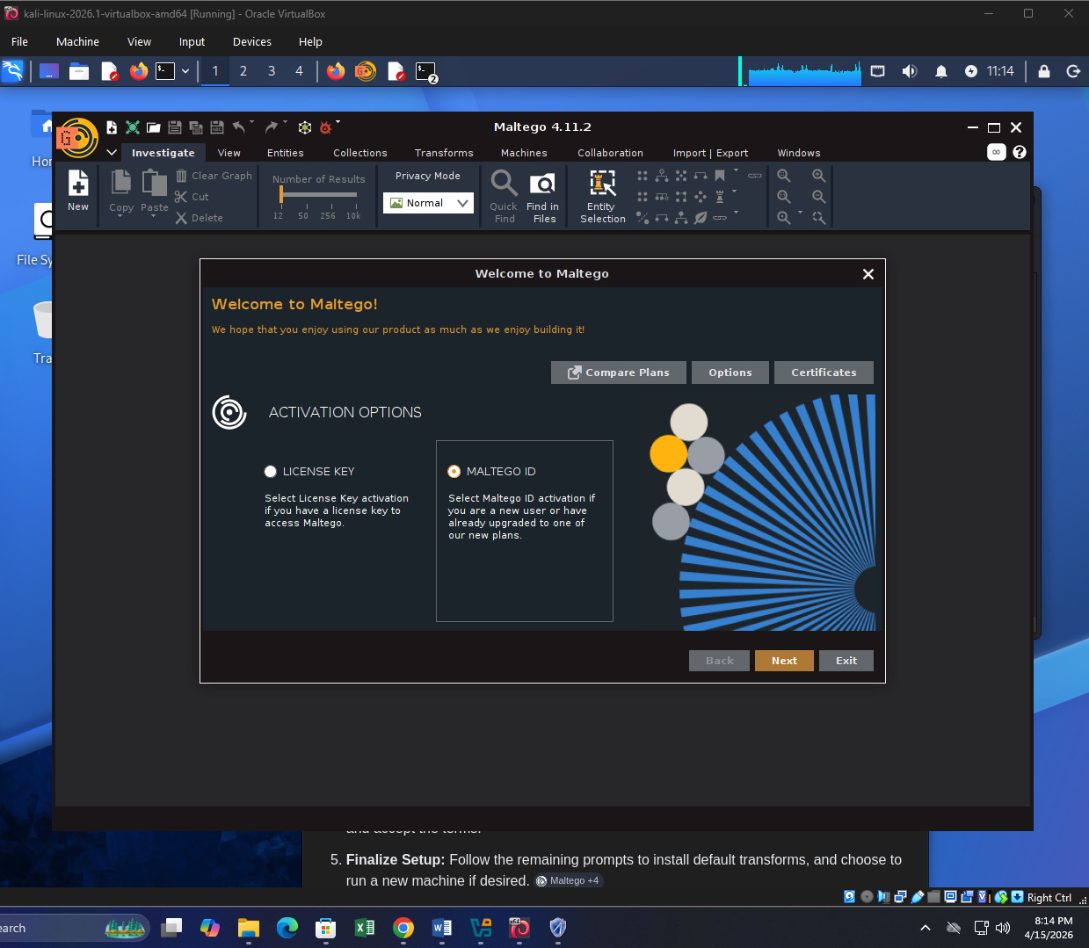

▶ Intelligence Report

- Who owns the domain? (WHOIS data)

Registrar: Network Solutions, LLC

- What IP addresses are associated?

Server: 192.168.1.1
Address: 192.168.1.1#53
Website address: Address: 162.241.216.11

- What emails or subdomains were found?

Registrar Abuse Contact Email: domain.operations@web.com
Registrar Abuse Contact Phone: +1.

- What ports/services are exposed on DNSDumpster?

ssh: SSH-2.0-OpenSSH_8.7
ftp: 20- Welcome to Pure-FTPd privsep TLS - 20-You are user number 1 of 150 alowed. 20-Local time is now
http: Apache
title: 404 Not Found
tech: Apache HTTP Server
https: Apache
title: 404 Not Found
cn: .bluehost.com
tech: Apache HTTP Server

